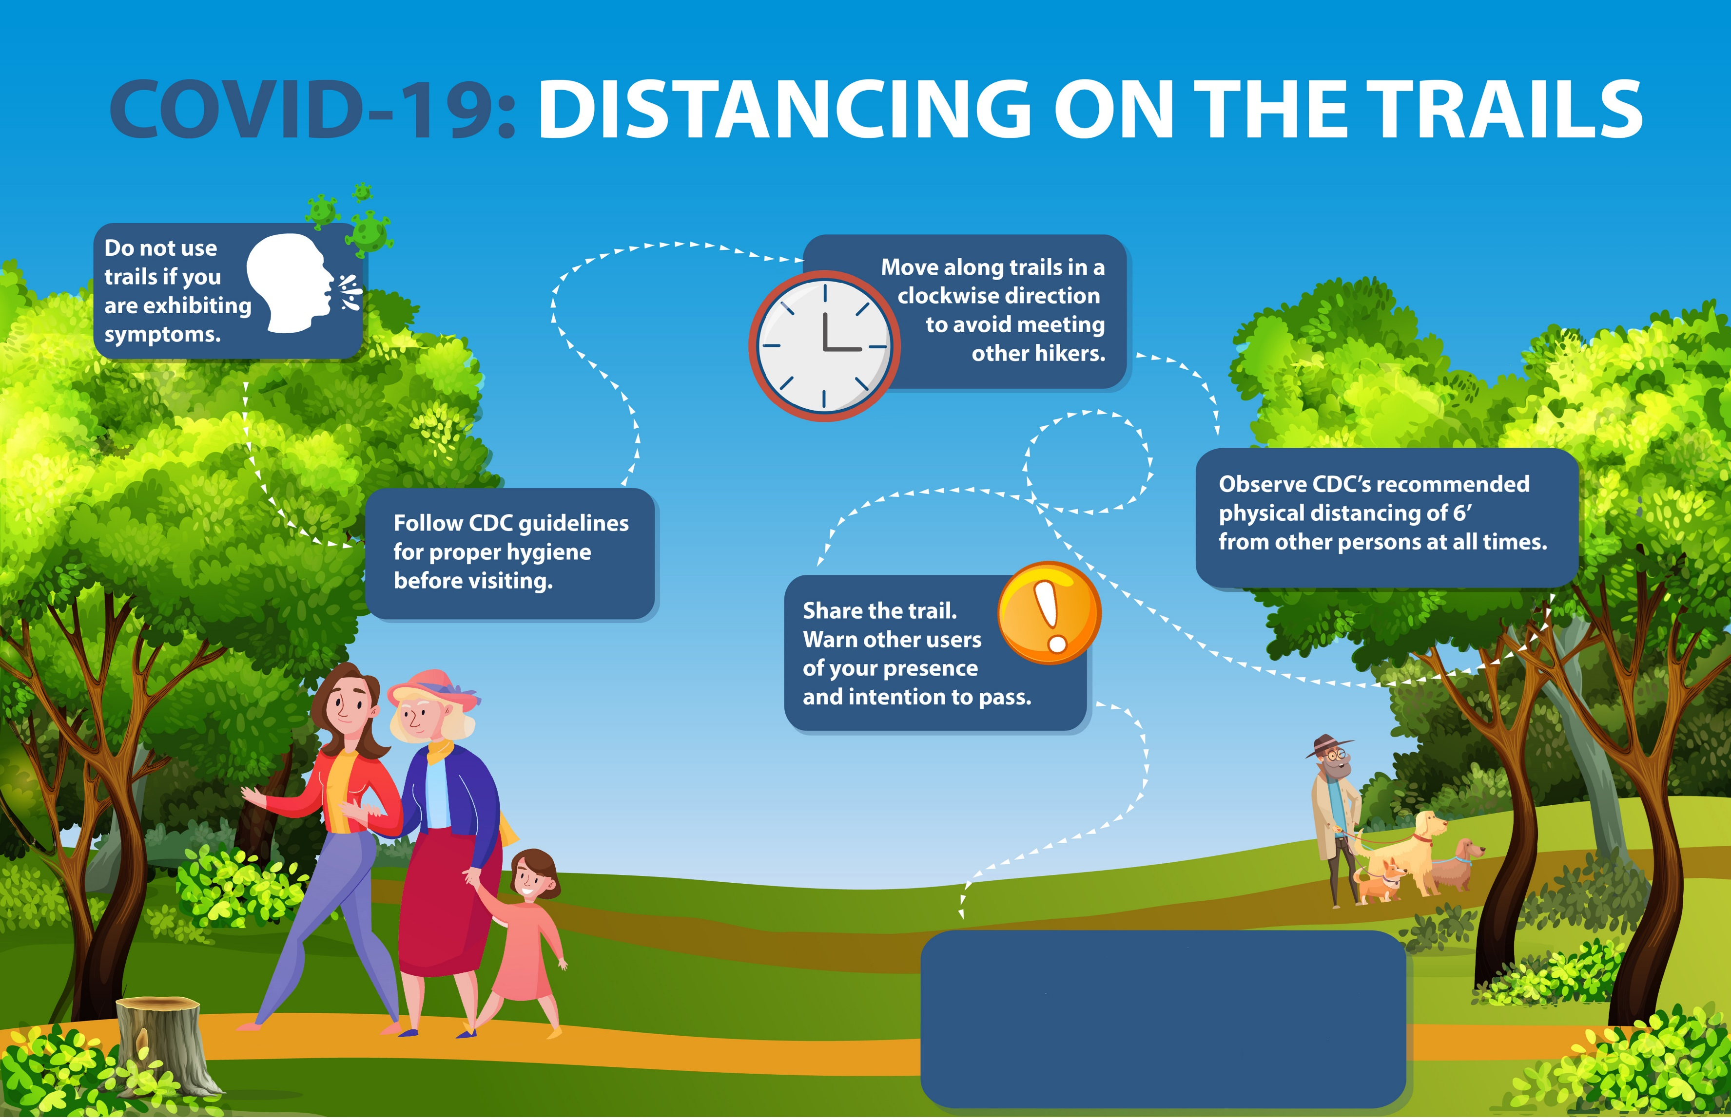

**For more Coronavirus rules, visit (insert your website here) or speak with our staff.**