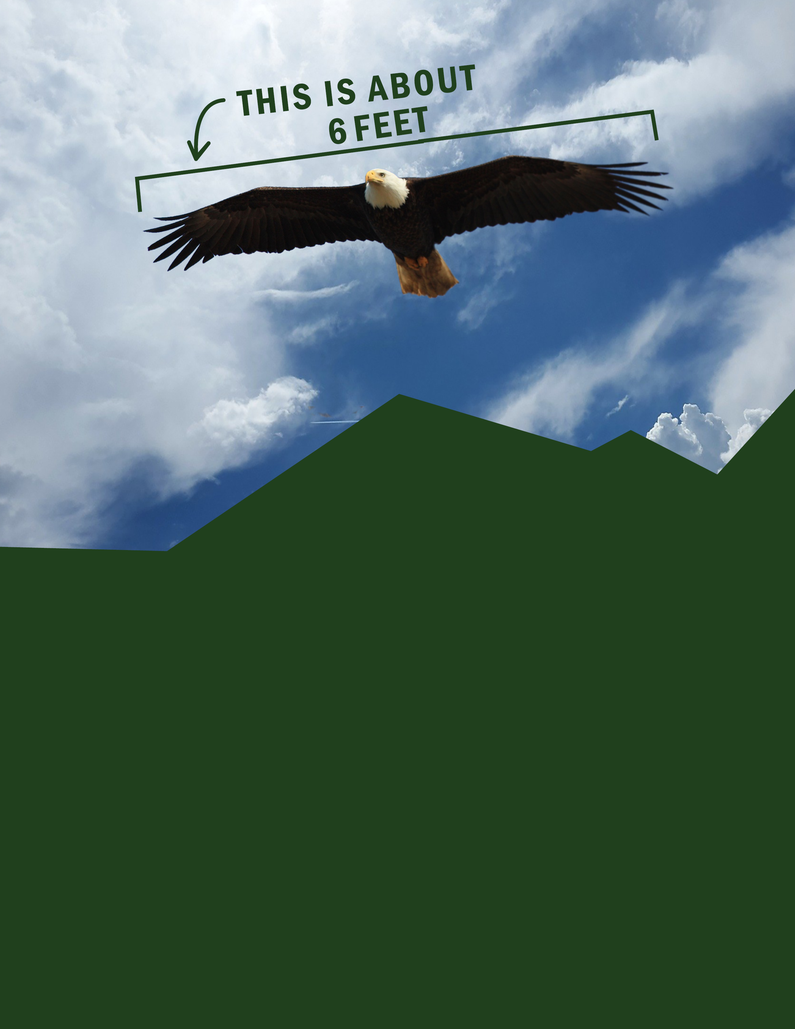******

*For the Safety of our Community…*

Keep 6 Feet   
Apart

**Find more resources from Marshall & Sterling Insurance at  
*www.naturecenterinsure.com***