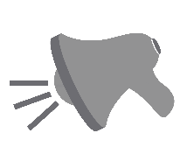

Find more resources at

*www.naturecenterinsure.com*

THE FOLLOWING Activities &   
Common Areas are CLOSED:

NO canoeing, waterfront, nature play area, team sports (add your activities/areas that are closed)

There are some new rules & temporary changes you need to be aware of…

WELCOME!

**Check out our webpage / Facebook / youtube page for updates:** Learn which areas are open, share photos and stories, challenges and solutions. Also, be sure to visit for our schedule of virtual and upcoming events. *Thank you for being understanding!*

**Marshall & Sterling Insurance**[***www.campgroundandhospitalityinsure.com***](http://www.campgroundandhospitalityinsure.com/)