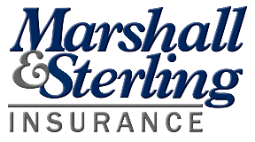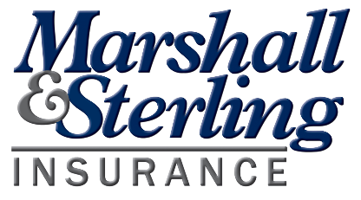

Find more resources from Marshall & Sterling Insurance at  
*www.naturecenterinsure.com*

* Maximum # of people allowed inside: _______
* Face Coverings are required to enter the Center. Face Coverings available upon request.
* Please wash your hands or sanitize before & after leaving the store
* Practice Physical/Social Distancing - Stay 6 feet apart from shoppers and staff! Even when waiting in line
* Sneeze into your elbow or a clean tissue

For your safety & the safety of our staff  
children and volunteers.

STORE RULES

**Marshall & Sterling Insurance**[***www.campgroundandhospitalityinsure.com***](http://www.campgroundandhospitalityinsure.com/)