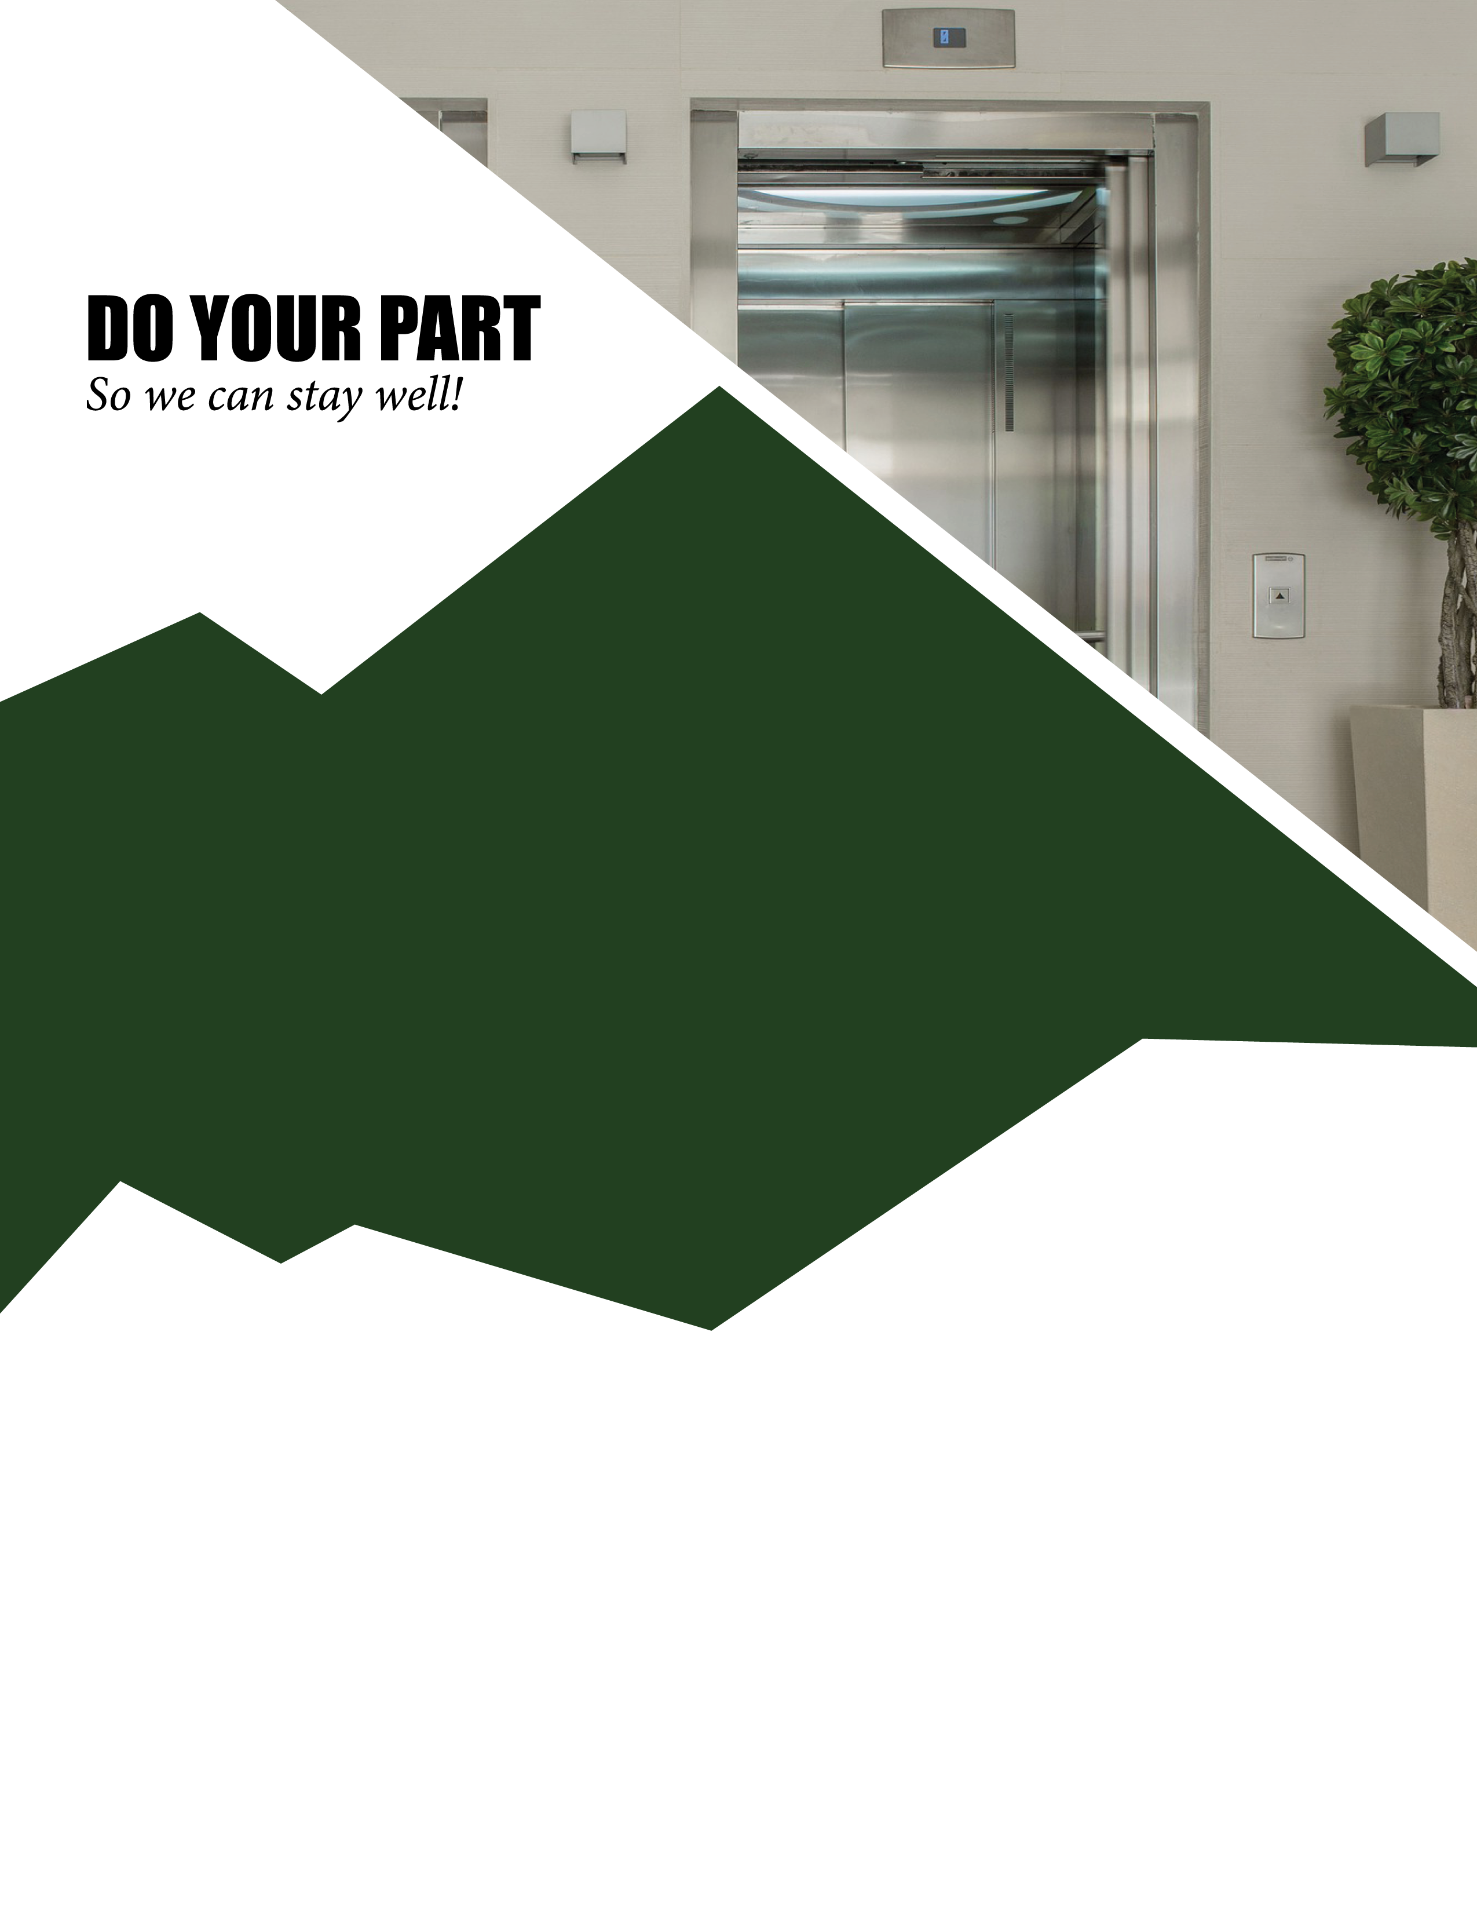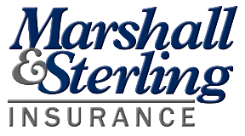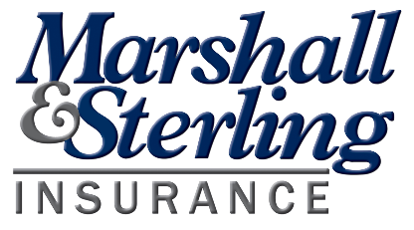

Elevator Capacity

is Limited

**To ensure a safe & sanitary center,   
the elevator capacity is limited to [4] individuals at a time.**

**We apologize for any inconvenience and thank you for your flexibility.**

Find more resources from Marshall & Sterling Insurance at  
*www.naturecenterinsure.com*

**Marshall & Sterling Insurance**[***www.campgroundandhospitalityinsure.com***](http://www.campgroundandhospitalityinsure.com/)