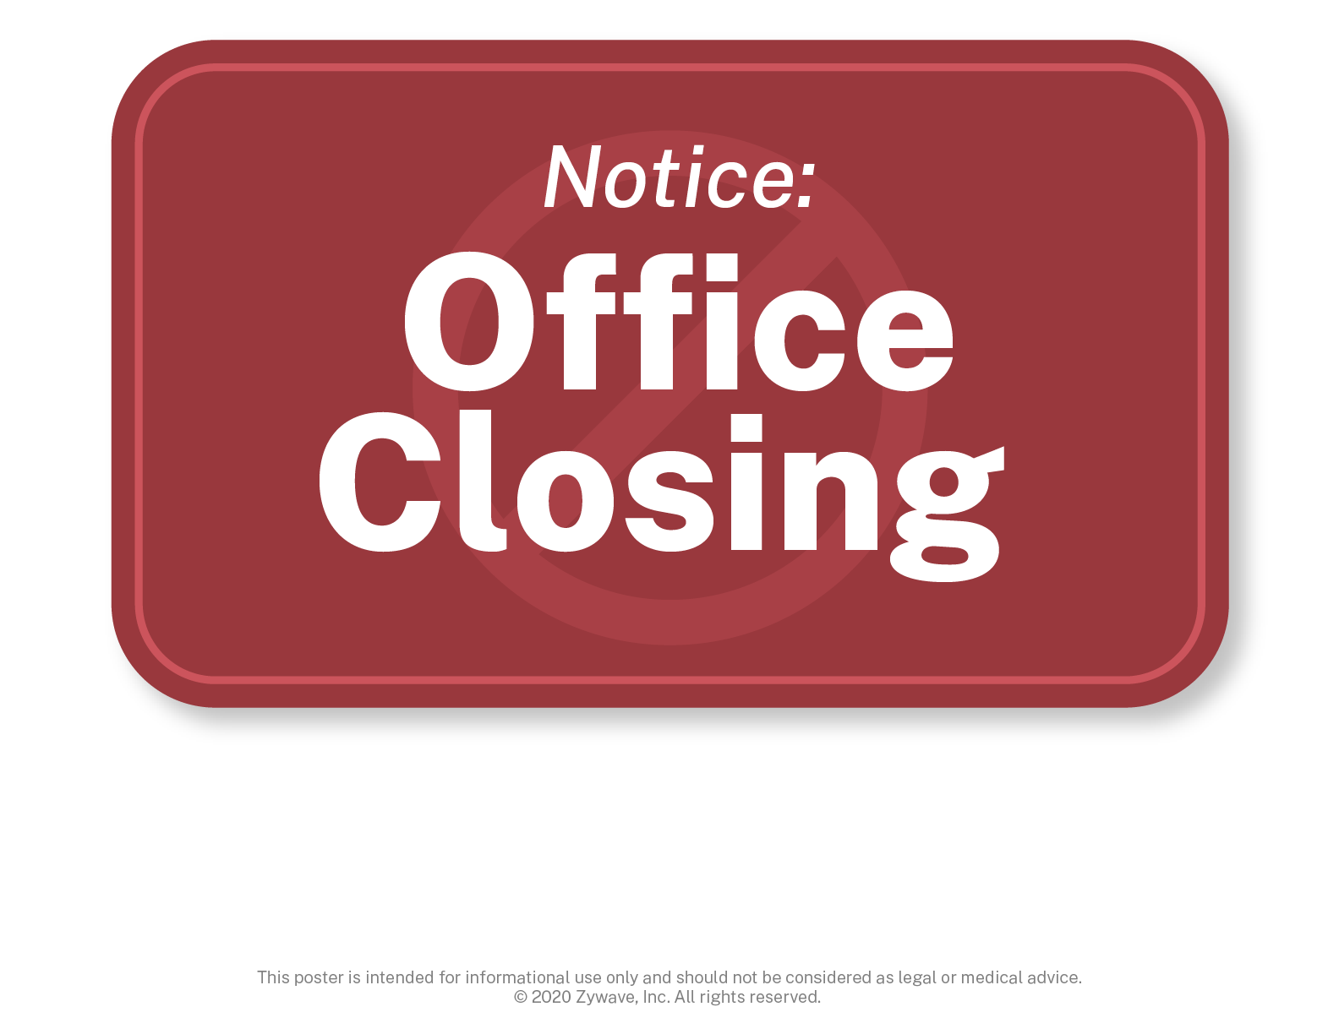

At , we prioritize the health and safety of all of our employees. In the wake of the   
COVID-19 pandemic, we’ve made the difficult decision to temporarily close our office until further notice.   
This decision was made to help keep our employees and their families healthy and safe.

For more information on the temporary office closing, please contact your manager or HR.