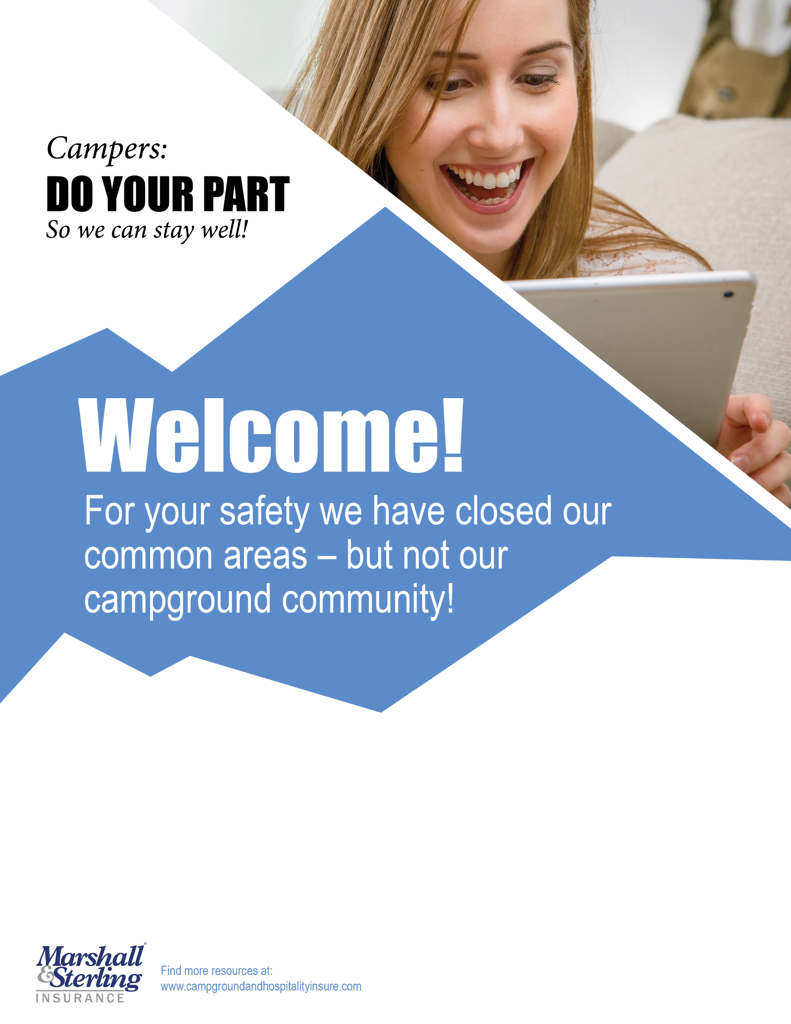

Our Activities and   
Common Areas are CLOSED:

NO Campfires, Visitors, Rec Hall, Pool, Waterfront, Playground, Team Sports

**Check out our webpage / facebook / youtube page for group activities like:** book clubs, hiking trails, mom’s groups, prayer groups and Campground sing a longs. We have a welcome camper conference call at (list conference number and code) every (day of week). Welcome and chat with neighbors, share stories, challenges and solutions. Click here for our schedule of virtual events. *Thank you!*

**Marshall & Sterling Insurance**[***www.campgroundandhospitalityinsure.com***](http://www.campgroundandhospitalityinsure.com/)