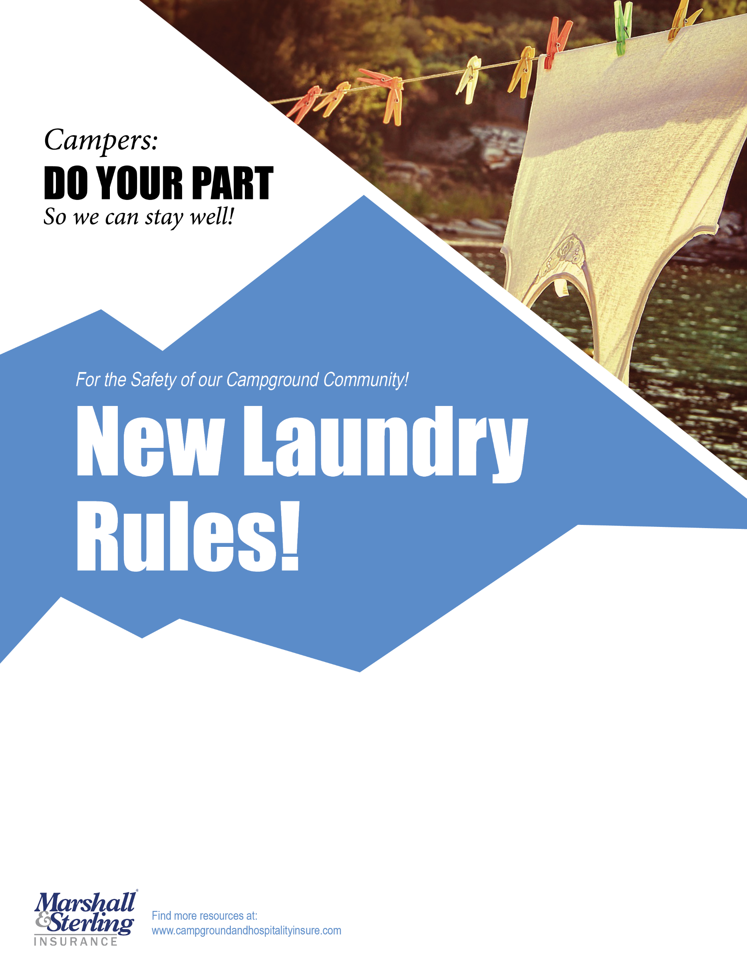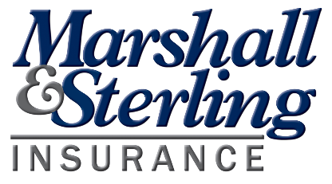

**Marshall & Sterling Insurance**[***www.campgroundandhospitalityinsure.com***](http://www.campgroundandhospitalityinsure.com/)

**Thank you for understanding that during COVID-19   
our Laundry will have new rules:**

* All people must be 6 feet apart
* The Laundry will be cleaned and disinfected every hour